Jessica Steffel
(I’ve only been a Steffel for a few months. I used to be Jessica Barth so I still accidentally call
myself that once in a while. 30 years is a long time to be one person and suddenly have a new name!)
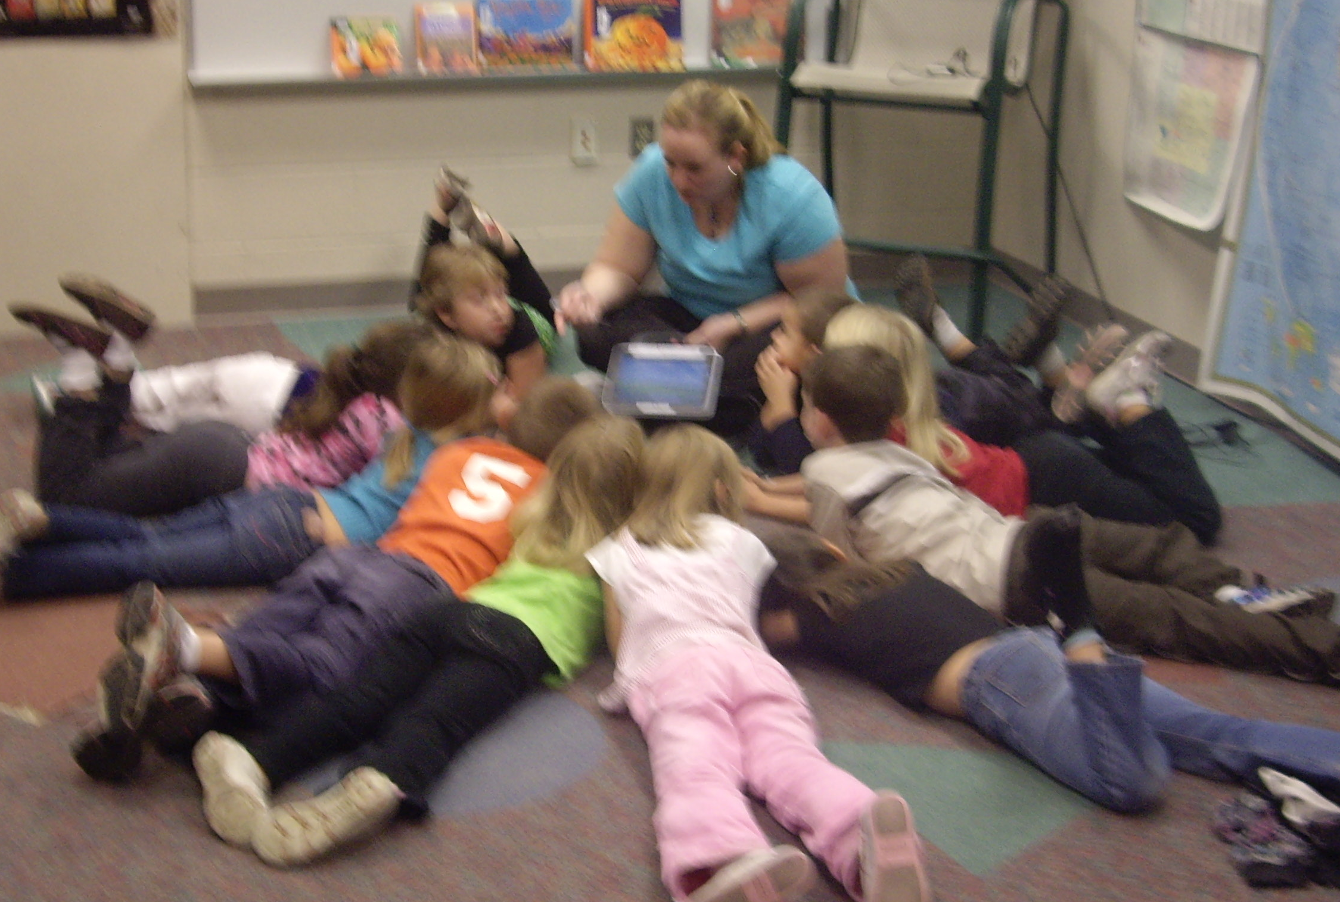
About Me:
K-1 Multiage Teacher
(http://multiage.wetpaint.com)

Graduate of Saginaw Valley State University (2002) with Elementary Education, Early Childhood Education, and COATT endorsement

I also have 18 credits of my master’s degree at SVSU in reading, but I have abandoned it for my true love, TECHNOLOGY!

My Journey to Tech Guru
(and to the Differentiated Instruction Model)
I define myself as a teacher using these criteria: I’m effective at using technology and getting students to use it even at the young age of 5, AND I don’t teach “one-size fits all.” From the time I first heard of Vygotsky’s philosophy of the Zone of Proximal Development, I knew that was what I believed about learning and I continue to work to put that in practice. It is NOT easy and I feel like I never stop working, but it is intensely satisfying to know that students feel challenged yet supported and enjoy themselves along the way.

HIGH SCHOOL: The first time I remember noticing my natural ability to pick up computer skills was when I took typing as a junior in high school. I ended up independently completing three semesters worth of classes in two semesters. I took myself through all the MS Office tutorials they had. I really appreciated that my teacher let me work at my own pace, and I remember this when I have advanced students that need to be challenged.

COLLEGE: I had some rare opportunities. As a research junkie, I wanted to work on the research floor of the library. Sadly, those jobs were filled and they stuck me across campus in the professors’ media checkout center. I began to work with professors in their personal computer lab attached to the office and I was offered a higher paying job to teach them computer skills to put their classes online. I spent two years running workshops to teach professors to put their classes on Blackboard, an online learning platform. I also helped maintain the university website with Dreamweaver. In addition, I was part of the Honors program. To complete my honors thesis, I built my ideal classroom website. Now there are much easier (and free) ways to build websites, but I was pretty proud of it at the time.

AS A TEACHER: My first teaching job included no computers, and not even a telephone in the room. Fortunately, I was laid off and got a new job in Grayling. I had five networked computers in my 1st grade classroom, which was a dream come true! In fact, it was my experience with technology that got me that job over the other 181 applicants!

My role as tech guru emerged. I remember the first time I said to my principal, “I could just show everyone at a staff meeting.” Over the next few years that evolved into monthly technology meetings, writing a database for all of our school data, and many chances to help staff figure out technology for themselves and their classrooms. There’s a myth among the staff that I can do anything on a computer. That’s not true; I just have the tenacity to figure it out!

I love my teaching, but I wish I could have the time to help the other teachers in my building to do what I do. They all want to and just don’t know how. It’s like asking them to teach Greek; they don’t know it but they have to teach it and they are frustrated. Working with our teachers, I understand the value of the teachable moment. I can run workshops forever, but until they are ready to implement a project and need that information, it doesn’t stick. So even with teaching the teachers, I try to differentiate my instruction to try to fit everyone’s needs and interests.

How I Learn Best: Individually
I learn best individually when there are clear expectations and good follow-up (especially if it is for someone else, like my boss) or if it’s something I’m internally driven to do. I’m not one to give up, and I will play with it until I figure it out.
I also learn best if I’m given time to think about my work. My favorite thinking place is my car, where I can talk ideas out to myself. I’m not so great on the spot and have been known to draw a complete blank about things I know well.

How I Learn Best: With Others
I learn best in a group when I have an opportunity to affect others. Bringing someone on board for an idea that they previously were wary about is the best feeling! I am a perfectionist and unfortunately, I sometimes put that on others as well. However, I’m always willing to teach someone who wants to learn; and I can make myself figuratively sit on my hands and guide them so that they learn it, too.
I enjoy making polished final products and I have a good sense of how to make that happen. It’s the kind of detail I notice.
In a group, I don’t have a lot of tolerance for complainers. I will join in a minimal amount of whining when appropriate and then I just want to get the job done.
I think I was born late, because timeliness and keeping ahead of the game are not my strong suite. I usually have to rely on someone else to be looking ahead to see what’s coming and help manage deadlines. I will write it on my calendar and never look at it. Whoops!

